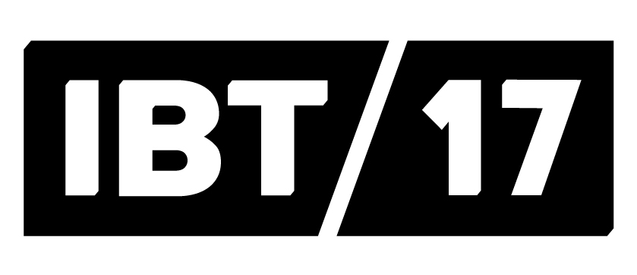
Wednesday 2nd November
In Between Time launches IBT17 Bristol International Festival
International arts producer, In Between Time (IBT) that previously brought the Fog Bridge to Bristol has launched the full programme for IBT17 Bristol International Festival as tickets go on sale.
The biennial event will take place from Wednesday 8th to Sunday 12th February in various locations across the city, from theatres and galleries to city streets, and outdoor spaces.
More than 30 events across dance, theatre, live art, activism and music will be performed over the five day festival to tell stories that surprise, inspire and affect change. Themed around the topic ‘Stand Up, Stand Out’ the festival will feature 40 exceptional artists unafraid to stand up for their beliefs as the world changes, portraying a version of Britain that is contemporary, open and defiantly different.
The festival will open at midday on Wednesday 8th February with a 12 hour performance of the Lone Twin’s legendary Ghost Dance. Two performers dressed as cowboys, blindfolded and silent will begin to dance, perfectly matching each other’s footsteps. As time goes on, members of the public are expected to step in, to support them when exhaustion starts to kick in.
The highlight of IBT17 Bristol International Festival will be the UK Premiere of The Record by the award-winning New York theatre company 600 HIGHWAYMEN. Performed at the Bristol Old Vic from Thursday 9th to Saturday 11th February this unique performance features 45 Bristolians who have been selected following auditions and will be individually coached in the lead up to the festival. The performers will come together for the first time on stage, not knowing who they will meet when they start to perform.
Helen Cole, Artistic Director/CEO of In Between Time, commented: “This is our bravest festival yet. Our 40 truly exceptional artists offer a version of Britain that is uncompromisingly contemporary, open and defiantly different.
“For this year’s festival we are incredibly honoured to be working with New York’s convention-smashing theatre company, 600 HIGHWAYMEN for the UK premiere of The Record which will truly represent Bristol and is sure to be a highlight of the programme.”
Other programme highlights include:
Lone Twin’s Beastie is a creation, conjured from the imaginations of children. Beastie will arrive in Bristol and pop-up at unexpected times and in the least likely locations over the course of the festival. At first Beastie may be met with trepidation but overtime the city begins to welcome the creature in as children are invited to attend workshops over the five days to imagine and complete Beastie’s story.
Between Thursday 9th and Friday 10th February two artists will perform at The Wardrobe Theatre. Katy Dye’s Baby Face explores the paradox of a society that encourages boys to be men but women to be girls, while Rachael Young’s Out challenges homophobia within Caribbean communities. Katy and Rachael along with four other artists, John Smith, Vivian Chinasa Ezugha, FK Alexander and Hannah Sullivan have been commissioned as part of the New Bloods Platform which develops the next generation of UK performers and live artists, in partnership with Leeds Beckett University, University of Chichester and the University of the West of England
Also running from Thursday 9th – Sunday 12th in a secret location is Woodland, a performance which invites the audience to become at one with the forest. Artists French & Mottershead have produced a meditative audio work where the audience lie in a woodland location as a spoken narrative lets them imagine their body’s return to the soil over time.
A series of one-to-one performances will take place in the Arnolfini from Friday 10th to Sunday 12th February. Tania El Khoury’s As Far As My Fingertips Take Me is a conversation between an audience member and a refugee through touch and sound sharing stories of people who have recently challenged border discrimination while Rosana Cade’s My Big Sister Taught Me This Lap Dance invites audience members to sit still as Cade performs the lap dance her older sister taught her inside a small red lit booth exploring how we view women’s bodies.
Playing Up by the Live Art Development Agency is a role reversal game for children and adults, taking place at the Arnolfini on Saturday 11th and Sunday 12th February participants may find themselves dancing with animals, remote controlling an adult, searching for a miracle or following a random passer-by.
On Saturday 11th February the whole festival will be celebrated with a huge, immersive art party at The Station. The Dawn Art Party encourages party goers to summon their night owl or unleash their dawn creature. For one night only, sunrise and nightfall will wash over the former police and fire station as the party takes place from 10pm until 4am.
Following a national call out, IBT has commissioned one exceptional UK artist, Ria Hartley for the festival as the winner of the Wild Card Award 2017. In May 2013, Ria married herself by civil partnership, Look No Further is her post wedding reception dinner inviting an audience as her guests to this unique celebration at Trinity Centre on Sunday 12th February.
For the duration of the festival the Arnolfini Cafe Bar will be at the heart of the action, acting as the Festival Hub and Late Night Bar for artists, delegates and festival goers. Within walking distance of most IBT17 venues, the hub will be a social space to plan the day and have a drink and chat with other festival attendees.
For the full programme and to book tickets please visit the IBT website, inbetweentime.co.uk. For more information also find us @In_Between_Time on Twitter and @InBetweenTime on Facebook and Instagram.
ENDS
For more information please contact Plaster Creative Communications on 0117 953 0320 or email:
Dani Andres, dani@weareplaster.com
Beryl Dzambo, beryl@weareplaster.com
Notes to editors:
The IBT17 Bristol International Festival programme has been curated by In Between Time in partnership with:
Principal Supports: Arts Council England, Bristol City Council
Supporters: British Council, Australia Council for Arts, Live Art Development Agency, Arnolfini, UWE Bristol
Media Partners: Crack Magazine, Bristol 247
Partners: Knowle West Media Centre, Up Our Street, Ambition Lawrence Weston, Bristol Old Vic, Ujima Radio, Bristol Festivals, Live Art UK, Trinity, Fierce, Attenborough Centre for the Creative Arts, University of Chichester, Leeds Beckett University, Colston Hall, The Station, Watershed, University of Bristol, Loco Klub, Limbic Cinema, The Wardrobe Cinema, Arnos Vale, At Bristol, Citizens UK, Creative Access, Bristol SU, Visit Bristol, The Island, Bristol Pride Festival

