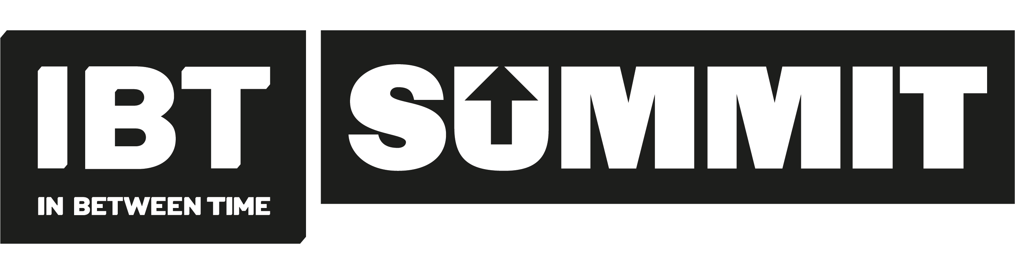
Creative Exchange Lab application form

Please note: We are happy to accept your answers to the application questions in a format which suits you. This includes written applications and links to video/audio. All applications will need to address the questions in this form.

PERSONAL DETAILS
Surname: | Other names:
Address:

Postcode:

Home telephone number: | Work telephone number:
Mobile telephone number: | E-mail address:

- Please select the preference of the international artist you wish to work with: in 1st, 2nd 3rd order.
 | Please circle | Or write first second third
Cigdem Aydemir | 1st 2nd 3rd
Dorothee Munyaneza | 1st 2nd 3rd
Kameelah Janan Rasheed | 1st 2nd 3rd

- A short response to the provocation by the artist whose workshop you hope to join

- Covering statement
A brief outline of why you would like to take part and why you feel you should be selected; (500 words max).

- SUPPORTING MATERIAL
- Please provide a summary of your previous practice. This could be in the an up to date CV or artist biog detailing your professional experience. Please make sure this includes details of the various duties and responsibilities you undertook in those roles.

- Please supply links to your website and examples of previous work (video, photos)

Please send your completed application and equal opportunities form to: opportunities@inbetweentime.co.uk

opportunities@inbetweentime.co.uk
If you would like further support with your application – please email or call us on 0117 3706383

DATA PROTECTION STATEMENT
- Your submission will be kept on a secure server and only accessed by appropriate staff at our organisation.
- Your application will be kept separate from your name and contact details throughout the selection process.
- Using the information provided in your application pack, we will only contact you regarding your application, this role, and the Creative Exchange Lab.
- Your equal opportunities form will be separated from your application upon receipt and will remain anonymous. Data collected will be used for reporting statistics to our stakeholders and once data has been recorded the form will be destroyed.

EQUALITIES MONITORING FORM
IBT aims to achieve equal opportunities throughout the organisation and in our recruitment procedure. The information we collect helps us to ensure that we implement and monitor our policy. All information you provide below will be kept confidentially and anonymously.
Age | Mark ‘X’ |  | Gender |  |  | Mark ‘X’
18-20 |  |  | Male
21-34 |  |  | Female
35-55 |  |  | Non-Binary
55+ |  |  | Prefer not to say
Is your gender identity the same as the gender you were assigned at birth?
Sexual Orientation | Mark ‘X’ |  |  |  |  | Mark ‘X’
Bisexual |  |  |  | Heterosexual
Gay Man |  |  |  | Gay Woman / Lesbian
Other |  |  |  | Prefer not to say
Ethnicity | Mark ‘X’ |  |  |  |  | Mark ‘X’
Asian |  |  |  | British
Bangladeshi |  |  |  | English
Chinese |  |  |  | Gypsy/Irish Traveller
Indian |  |  |  | Irish
Pakistani |  |  |  | Scottish
Other Asian background |  |  |  | Welsh
African |  |  |  | Other White background
Caribbean |  |  |  | White & Asian
Other Black background |  |  |  | White & Black African
Arab |  |  |  | White & Black Caribbean
Other Ethnic Group |  |  |  | Other mixed background
Prefer not to say
Disability |  | No |  |  | Yes
Do you consider yourself to have a disability?
If yes – please specify:
Please state how you found out about the Creative Exchange Lab:

